**Module -2**

**Google Cloud Platform**

**Products and Services**

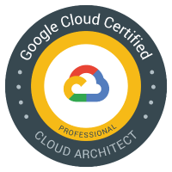

Sriram



Table of Contents

2 Google Cloud Platform Products and Services 3

2.1 Computing and hosting services 10

2.2 Storage and Database services 13

2.3 Networking services 17

2.4 Big data services 21

2.5 AI & ML services 24

2.6 Security & Identity services 27

# 2 Google Cloud Platform Products and Services

Google divides the product and services into the following logical groups:-

* Compute Services
* Storage and Database Services
* Networking Services
* Big data Services
* AI & Machine learning (ML) Services
* Identity Services

|  |  |
| --- | --- |
| **Compute Services** GCP provides a scalable range of computing options you can tailor to match your needs. It provides highly customizable virtual machines. and the option to deploy your code directly or via containers. The Compute domain it includes the following services:-   * Google Compute Engine * Google App Engine * Google Kubernetes Engine * Google Cloud Container Registry * Cloud Functions |  |
| **Storage and Database Services** The storage as the name suggests, is used to store data in the cloud, this data can be stored anywhere but content delivery on the other hand is used to cache data nearer to the user so as to provide low latency.  The database domain is used to provide reliable relational and non-relational database instances managed by GCP.  The Storage domain includes the following services:-   * Google Cloud Storage * Cloud SQL * Cloud Bigtable * Google Cloud Datastore * Persistent Disk |  |
| **Networking Services** It includes services which provide a variety of networking features such as security, faster access etc. The Networking domain includes the following services:-   * Google Virtual Private Cloud (VPC) * Google Cloud Load Balancing * Content Delivery Network * Google Cloud Interconnect * Google Cloud DNS |  |
| **Bigdata Services**  Bigdata services are used to process huge amount of data.  The Bigdata domain includes the following services:-   * Google BigQuery * Google Cloud Dataproc * Google Cloud Datalab * Google Cloud Pub/Sub |  |
| **AI & ML Services**  The AI & Machine learning domain includes the following services:-   * Cloud Machine Learning * Vision API * Speech API * Natural Language API * Translation API * Jobs API |  |
| **Security and Identity Services** It includes services for user authentication or limiting access to a certain set of audience on your AWS resources.  The Security domain includes the following services:-   * Cloud Resource Manager * Cloud IAM * Cloud Security Scanner * Cloud Platform Security |  |
| **Management Tools**  It includes services which can be used to manage and monitor your AWS instances. The tools related to monitoring and management includes the following services   * Stackdriver * Monitoring * Logging * Error Reporting * Trace * Cloud Console |  |
| **Developer Tools**  It helps the developers to build and deploy the applications.  The tools related to development, includes the following services:-   * Cloud SDK * Deployment Manager * Cloud Source Repositories * Cloud Test Lab |  |

**Overview of GCP Services**

|  |  |
| --- | --- |
| **Compute Services** | |
| Compute Engine | Run large scale workloads on virtual machines hosted on Google's infrastructure |
| App Engine | A platform for building scalable web apps and mobile backends |
| Container Engine | Run Docker containers on Google's infrastructure, powered by kubernetes |
| Cloud Functions | A Serverless platform for building event-based microservices triggered by events |
| Cloud Run | Fully managed environment for running containerized apps |
| **Storage & Database Services** | |
| Cloud Storage | Object Storage that’s secure, durable and scalable |
| File Store | File Storage that is highly scalable and secure |
| Persistant Disk | Block Storage for virtual machine instances running on Google Cloud |
| Cloud SQL | Relational database services for MySQL, PostgreSQL & SQL Server |
| Cloud Datastore | A managed, NoSQL, schema-less database for storing non-relational data |
| Cloud Fire Store | Cloud-native document database for building rich mobile, web and IoT apps |
| Cloud Spanner | Cloud-native relational database with unlimited scale and 99.999% availability |
| Bigtable | Cloud-native wide column database for large-scale, low-latency workloads |
| Memory Store | In-memory database for managed Redis and memcached |
| **Networking Services** | |
| Virtual Private Cloud | Virtual Network for Google Cloud Resources and Cloud Based Services |
| Load balancer | Services for distributing traffic across applications and regions |
| Virtual Private Network | VPNs allow a connection between your on-premises network and GCP VPC through an IPsec tunnel over the internet. |
| Cloud Interconnect | Connect your infrastructure to Google's network edge with enterprise grade interconnect |
| Cloud Router | Cloud Router is a service that allows for dynamic routing exchange between Compute Engine, VPNs, and external networks. It eliminates the need for the creation of static routes. |
| Cloud DNS | Domain Name System for reliable and low-latency name lookups |
| Cloud Content Delivery Network (CDN) | Content Delivery network for delivering video and web |
| Cloud NAT | NAT Service for giving private instances and internet access |
| Firewall | Global and flexible firewalls to protect your cloud resources |
| Cloud Armor | Security Policies and defense against web and DDoS attacks |
| **Bigdata Services** | |
| BigQuery | Datawarehouse for business agility and insights |
| Pub/Sub | Message Service for event ingestion and delivery |
| Dataproc | Service for running Apache Spark and Apache Hadoop Clusters |
| Dataflow | Streaming analytics for stream and batch processing |
| Dataprep | Service to prepare data for analysis and Machine Learning |
| Datalab | An easy-to-useinteractive tool for large-scale data exploration, analysis, andvisualization |
| Data Studio | Interactive Data Suite for Dashboarding, Reporting and Analytics |
| Cloud Composer | Workflow orchestration service built on Apache Airflow |
| **AI & Machine Learning Services** | |
| Cloud ML Engine | ML Engine is a managed service that allows you to train and host your ML models in GCP |
| Google Cloud Video Intelligence | Enable powerful content discovery and engaging video experiences |
| Google Cloud Speech | **Speech-to-Text** allows developers to convert audio to text by applying powerful neural network models in an easy-to-use API. Speech recognition and supporting 125+ languages.  **Text-to-Speech** synthesizes human-like speech based on input text in a variety of 220+ voices and 40+ languages. |
| Google Cloud Vision | Custom and pretrained models to detect emotion text and more.. |
| Google Cloud Natural Language | Sentimental Analysis and classification of unstructured text |
| Google Cloud Translation | Language detection, Translation and glossary support |
| AutoML | Custom Machine Learning Model training and development |
| Dialogflow | Conversational applications and system development suite for virtual agents |
| **Security & Identity Complaince** | |
| IAM | Permission Management System for Google Cloud Resources |
| Cloud Identity | Unified Platform for IT admins to manage user devices and apps |
| **Monitoring Tools** | |
| Stackdriver [Cloud Monitoring, Logging & Diagnostics] | Provides monitoring, logging, and diagnostics for applications built on cloud infrastructure including GCP and AWS. Stackdriver provides metrics, dashboards, alerting, log management , reporting, and tracing capabilities |
| Deployment Manager [Template-based Infrastructure Deployment] | An infrastructure automation and management service that allows you to define templates to deploy a variety of GCP services, including Cloud Storage, Compute Engine, and Cloud SQL |
| Cloud Shell [Browser-Based Terminal/CLI] | Command-line access to cloud resources from within a browser, without having to install the Google Cloud SDK or other tools on your system |
| Google Cloud Billing API [Programmatic GCP Billing Management] | Programmatically managed billing for your GCP projects |

**GCP Managed Services**

Installation, Upgrade, Patch, and Backup activity will be managed by the Google called Managed Services. Managed services can be serverless or non-serverless.

* **Serverless:** Cloud Dataflow, Cloud Big Query, Cloud Pub/Sub, …
* **Server-based:** GCE, GKE, Cloud Dataproc, …

**Serverless Vs Server-based Service**

|  |  |
| --- | --- |
| Serverless | Server-based |
| Serverless resources do not need to provision compute, memory, or network | Customer has to spin the virtual machine/cluster |
| Components for these services will be managed by Google Cloud Platform | Provision under network |
| The only requirement is to submit jobs | You will be paying for resources even they are idle |
| Google Cloud Platform will allocate resources during Job execution and deallocate when the job is complete | Customer is responsible for provisioning and de provisioning the resources |

## 2.1 Computing and hosting services

The Computing options in GCP are:-

* Infrastructure as a Service (IaaS): Google Compute Engine (GCE)
* Container as a Service (CaaS): Google Kubernetes Engine (GKE)
* Platform as a Service (PaaS): Google App Engine (GAE)
* Function as a Service (FaaS): Cloud Functions

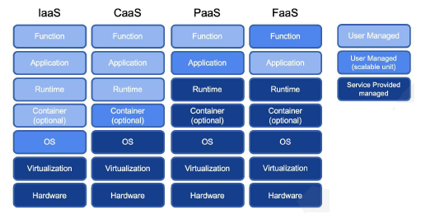



Google Compute Engine (GCE)

**Virtual Machines running on Google Cloud Datacenter’s**

* GCE is an IaaS offering. It allows the most flexibility as it provides compute infrastructure to provision Virtual Machine with options to utilize certain CPUs, GPUs, or Cloud TPUs. i.e., you have full control of the instance hardware and operating system. Virtual machines (VMs) in Google Cloud Platform are also known as instances.
* Use standard GCP images or your own custom image.
* You can control where your VMs and storage are located in terms of regions and zones. You have granular control over the network, including firewalls and load balancing.
* With the use of an instance group, you can autoscale your control and your capacity as needed. Compute Engine is suitable in most cases, but might not be an optimal solution.



Google Kubernetes Engine (GKE)

**Managed environment for running container apps**

* GKE is a CaaS offering. It allows you to create Kubernetes clusters on demand, which takes away all of the heavy lifting of installing the clusters yourself.
* It leverages Compute Engine for hosting the cluster nodes, but the customer does not need to bother with the infrastructure and can concentrate on writing the code. The provision cluster can be automatically updated and scaled.
* The GCP softwaredefined networks are integrated with GKE and allow users to create network objects, such as load balancers, on demand when the application is deployed.
* Several services integrate with GKE, such as a container repository, which allows you to store and scan your container images.



Google App Engine (GAE)

**Serverless Application Platform for Apps and Backends**

GAE is a PaaS offering. It allows you to concentrate on writing your code, while Google takes care of hosting, scaling, monitoring, and updates. It is targeted at developers who do not need to understand the complexity of the infrastructure.

GAE offers two types of environments,as follows:

* **Standard**: With sets of common languages supported
* **Flexible**: Even more languages, with the possibility of creating a custom runtime

With a flexible environment, you lose some out-of-the-box integration, but you gain more flexibility. GAE is tightly integrated with GCP services, including databases and storage. It allows versioning of your application for easy rollouts and rollbacks.



Cloud Functions

**Event driven compute platform for cloud services and apps**

* Cloud Functions is an FaaS offering. It allows you toconcentrate on writing your functions in one of the supported languages.
* It is ideal for executing simple tasks for data processing, mobile backends, and IoT.
* This service is completely serverless and all of the layers below it are managed by Google. The functions can be executed using an event trigger or HTTP endpoint.



Cloud Run

**Fully managed environment for running containerized apps**

## 2.2 Storage and Database services

Section I Storage Services

Storage is an essential part of cloud computing as it saves the data and state of your applications. GCP offers a wide variety of storage, from object storage to managed databases.



Cloud Storage

**Object Storage that’s secure, durable and scalable**

* Cloud Storage is a fully managed, object-oriented storage service with infinite capacity. It allows the creation of buckets that store your data and allow access through APIs and other tools such as **gsutil**.
* It comes with different flavors to best suit your needs in terms of how often your data will be accessed and where it should be located. Keep in mind that the price differs for each tier. Making a conscious decision will allow you to cut costs. You can choose from the following options:

**Multi-regional**: The highest availability in multiple geolocations

**Regional**: High availability with fixed locations

**Nearline**: Low-cost, for data accessed less than once a month

**Coldline**: The lowest cost for backup and disaster recovery

* With Cloud Storage, you do not need to worry about running out of capacity.



File Store

**File Storage that is highly scalable and secure**

* Cloud Filestore is a managed file storage service. It allows users to provision a **Network Attached Storage** (**NAS**) service that can be integrated with GCE and GKE.
* It comes with two performance tiers —**standard** and **premium**, which offer different **Input/Output operations Per Second** (**IOPS**) and throughputs.



Persistant Disks

**Block Storage for virtual machine instances running on Google Cloud**

Section II Database Services

A database is an organization of data through which data can be easily accessed, managed, and updated. It provides reliable relational and non-relational database instances managed by GCP.



Cloud SQL

Relational database services for MySQL, PostgreSQL & SQL Server

* Cloud SQL is a fully-managed relational database service providing either a MySQL or PostgreSQL database.
* It offers data replication, backups, data exports, and monitoring. It is ideal when you need to move your current instances from on-premises and want to delegate the maintenance of the database to Google.



**Cloud Datastore**

A managed, NoSQL, schema-less database for storing non-relational data

* Cloud Datastore is a fully managed non-SQL database. It is ideal for applications that rely on highly available structured data at scale.
* The scaling and high availability is achieved by distributed architecture and is abstracted from the user. There is only one database available per project. Cloud Datastore offers SQL-like language to query your data



**Firestore**

**Cloud-native document database for building rich mobile, web and IoT apps**

* Firestore is the next generation of Cloud Datastore with several enhanced features. It can run in Native or Datastore mode. The former is compatible with Cloud Datastore.
* Google has announced that all Datastore clients will be automatically moved to Firestore without any downtime or any user intervention. All new projects should be created in Firestore instead of Datastore



**Cloud Spanner**

**Cloud-native relational database with unlimited scale and 99.999% availability**

* Cloud Spanner is a fully managed, globally distributed, and highly consistent database service. It is a strong and consistent relational database with non-relational database scaling capabilities.
* Users can define a schema and leverage industry-standard American National Standards Institute (ANSI) 2011 SQL. It is very highperforming, with a 99.999% availability Service Level Agreement (SLA), meaning there is almost no downtime applicable.
* Cloud Spanners are aimed at use cases such as financial trading, insurance,global call centers, telecoms, gaming, and e-commerce. Global consistency makes it ideal for globally accessible applications.



**Bigtable**

**Cloud-native wide column database for large-scale, low-latency workloads**

* Bigtable is a fully managed, massive scale, non-SQL database with sub-10 ms latency. It is used by Google to deliver services such as Gmail and Google Maps. It is ideal for fintech, IoT, and ML storage use cases.
* It integrates easily with big data product families such as **Dataproc** and **Dataflow**. It is based on open source Apache HBase, enabling the use of its API. The cost of Bigtable is much higher than Datastore, so the database should be chosen with great care.



**Memory Store**

**In-memory database for managed Redis and memcached**

* Cloud Memorystore is a managed Redis service. Redis is an open source, in-memory data store, which is designed for sub millisecond data access.

**Custom databases**

You can also choose to use Compute Engine to install a database of your choice, such as MongoDB; however, that would be an unmanaged service.

## 2.3 Networking services



**Virtual Private Cloud (VPC)**

**Virtual Network for Google Cloud Resources and Cloud Based Services**

* The VPC is the foundation of GCP networking. Each GCP project has a default VPC network created, but the user can also create new networks. You can think of it as a cloud version of a physical network.
* A VPC can contain one or more regional subnets. A VPC creates a global logical boundary that allows communication between VMs within the same VPC. To allow communication between VPCs, traffic needs to traverse the internet or via VPC peering.



**Load balancer**

**Services for distributing traffic across applications and regions**

Load balancer allows the distribution of traffic between your workloads. It is available for GCE, GAE, and GKE. For GCE, you can choose from load balancers with global or regional scopes. The choice will also depend on the network type.

The following load balancers are available to choose from:

* HTTP(S) load balancer
* SSL proxy load balancer
* TCP proxy load balancer
* Network load balancer
* Internal TCP/UDP load balancer



**Virtual Private Network (VPN)**

**VPNs allow a connection between your on-premises network and GCP VPC through an IPsec tunnel over the internet**. Only site-to-site VPNs are supported. To establish a VPN connection, there needs to be two gateways on each side of the tunnel. The traffic in transit is encrypted. Both static and dynamic routing are supported, with the former requiring a cloud router. Using a VPN should be the first method of connecting your environment to GCP as it entails the lowest cost. If there are low-latency and high-bandwidth requirements, then Cloud Interconnect should be considered.



**Identity Aware Proxy (IAP)**

**Use Identity and Context to guard access to your applications and VMs**

IAP is a service that replaces the VPN when a user is working from an untrusted network. It controls access to your application based on user identity, device status, and IP address. It is part of Google's BeyondCorp security model.



**Cloud Interconnect**

**Connect your infrastructure to Google's network edge with enterprise grade interconnect**

If there is a need for low latency and a highly available connection, then interconnect should be considered. In this case, the traffic does not traverse the internet.

There are two interconnect options, which are as follows:

* **Dedicated Interconnect**: 10 Gbps piped directly to a Google datacenter
* **Partner Interconnect**: 50 Mbps-10 Gbps piped through a Google partner

Multiple pipelines can be used to multiply the bandwidth.



**Cloud Router**

Cloud Router is a service that allows for dynamic routing exchange between Compute Engine, VPNs, and external networks. It eliminates the need for the creation of static routes.



**Cloud DNS**

**Domain Name System for reliable and low-latency name lookups**

Cloud DNS is a managed DNS service with a 100% SLA. It translates domains into IP addresses. Millions of zones and records can be managed. Cloud DNS can also host private zones accessible only from your GCP network. It can be integrated on-premises, where yourlocal DNS is authorized and Cloud DNS is responsible for caching.



**Cloud Content Delivery Network (CDN)**

**Content Delivery network for delivering video and web**

Cloud CDN is a service that allows the caching of HTTP(S) load balanced content, including Cloud Storage bucket objects. Caching reduces content delivery time and cost. It can also protect you from a Distributed Denial-of-Service (DDoS) attack. Data is cached on Google's globally distributed edge points. On the first request, when content is not cached, data is retrieved from a backend service. The next call data will be served directly from the cache until the expiration time is reached.



**Cloud NAT**

**NAT Service for giving private instances and internet access**

Cloud NAT is a regional service that allows VMs without external IPs to communicate with the internet. It is a fully managed service with built-in autoscalability. It works with both GCE and GKE. It is a better alternative for NAT instances that need to be managed by users.



**Firewall**

**Global and flexible firewalls to protect your cloud resources**

GCP Firewall is a service that allows for micro-segmentation.Firewall rules are created per VPC and can be based on IPs, IP ranges,tags, and service accounts. Several firewall rules are created by default

but can be modified.



**Cloud Armor**

**Security Policies and defense against web and DDoS attacks**

Cloud Armor is a service that allows protection against infrastructure DDoS attacks using Google's global infrastructure and security systems. It integrates with global HTTP(S) load balancers and blocks traffic based on IP addresses or ranges. Preview mode allows users to analyze the attack pattern without cutting off regular users.

## 2.4 Big data services



**BigQuery**

**Datawarehouse for business agility and insights**

BigQuery is a highly scalable and fully managed cloud data warehouse. It allows users to perform analytics operations with built-in ML. BigQuery is completely serverless and can host petabytes of data.

The underlying infrastructure scales seamlessly and allows parallel data processing. The data can be stored in BigQuery Storage, Cloud Storage, Bigtable, Sheets, or Google Drive. The user defines datasets containing tables. BigQuery uses familiar ANSI-compliant SQL for queries and provides ODBC and JDBC drivers. Users can choose from two types of payment models—one is flexible and involves paying for storage and queries, and the other involves a flat rate with stable monthly costs. It is ideal for use cases such as predictive analysis, IoT, and log analysis, and integrates with GCP's big data product family.



**Pub/Sub**

**Message Service for event ingestion and delivery**

This is a fully managed asynchronous messaging service that allows you to loosely couple your application components. It is serverless with global availability. Your application can publish messages to a topic or subscribe to it to pull messages. Pub/Sub can also push messages to **Webhooks**.



**Dataproc**

**Service for running Apache Spark and Apache Hadoop Clusters**

Dataproc is a fully managed **Apache Spark and Hadoop cluster**. It allows users to create clusters on demand and use them only when data processing is needed. It is billed per second. It allows users to move already existing, on-premises clusters to the cloud without refactoring the code. The use of pre-emptible instances can further lower the cost.



**Dataflow**

**Streaming analytics for stream and batch processing**

Cloud Dataflow is a fully-managed service for processing data in streams and batches. It is based on open source Apache Beam, is completely serverless, and offers almost limitless capacity. It will manage resources and job balancing for the user. It can be used for use cases such as online fraud analytics, IoT, healthcare, and logistics.



**Dataprep**

**Service to prepare data for analysis and Machine Learning**

This is a tool that can be used to perform data visualization and exploring without any coding skills being required. Data can be interactively prepared for further analysis.



**Datalab**

**An easy-to-useinteractive tool for large-scale data exploration, analysis, andvisualization**

Datalab is a built-in tool on Jupyter (formerly IPython) thatallows users to explore, analyze, and transform data. It also allows users to build ML data models and leverages Compute Engine.



**Data Studio**

**Interactive Data Suite for Dashboarding, Reporting and Analytics**

This a tool that allows you to consume data from sources and visualize it in the form of reports and dashboards.



**Cloud Composer**

**Workflow orchestration service built on Apache Airflow**

This is a fully managed service based on open source Apache Airflow. It allows you to create and orchestrate big data pipelines.

## 2.5 AI & ML services

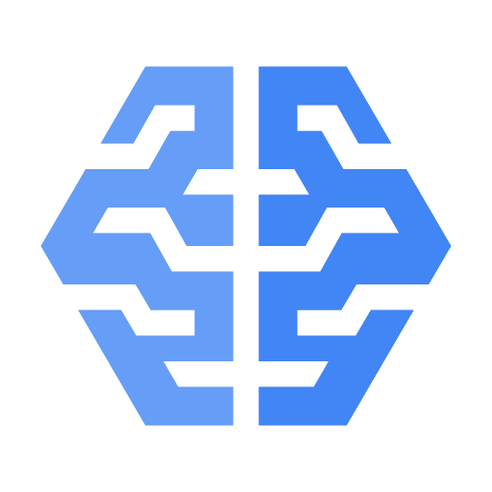

**Cloud ML Engine**

ML Engine is a managed service that allows you to train and host your ML models in GCP. It leverages the TensorFlow application for the training process. The underlying infrastructure is managed by Google, while users can choose from different hardware options. The trained model can be accessed through APIs to perform predictions. Fully managed machine learning service, Familiar notebook-based developer experience. Optimized for Google infrastructure; integrates with BigQuery and Cloud Storage.

**Pretrained APIs**

ML APIs are services that allow you to leverage several pre-trained models, enabling you to analyze a video. Currently,the following APIs are available:

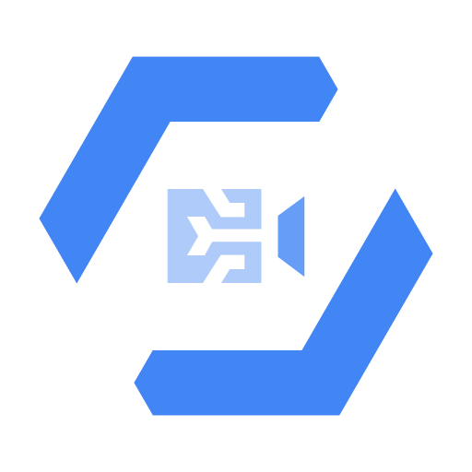

**Google Cloud Video Intelligence**

Enable powerful content discovery and engaging video experiences.

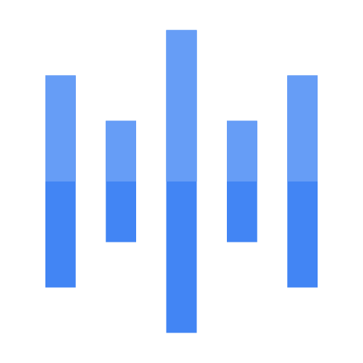 

**Google Cloud Speech**

Speech-to-Text allows developers to convert audio to text by applying powerful

neural network models in an easy-to-use API. Speech recognition and supporting 125+ languages.

Text-to-Speech synthesizes human-like speech based on input text in a variety

of 220+ voices and 40+ languages.



**Google Cloud Vision**

Custom and pretrained models to detect emotion text and more..

Derive insights from your images in the cloud or at the edge with AutoML Vision or use pre-trained Vision API models to detect emotion, understand text, and more..



**Google Cloud Natural Language**

Sentimental Analysis and classification of unstructured text. Derive insights from unstructured text using Google machine learning

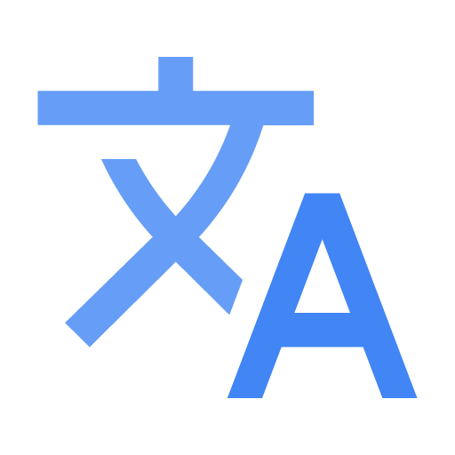

**Google Cloud Translation**

Language detection, Translation and glossary support.

Dynamically translate between languages using Google machine learning. These models can be used without any background knowledge of how they work. As an example, we can analyze text for sentiment analysis.

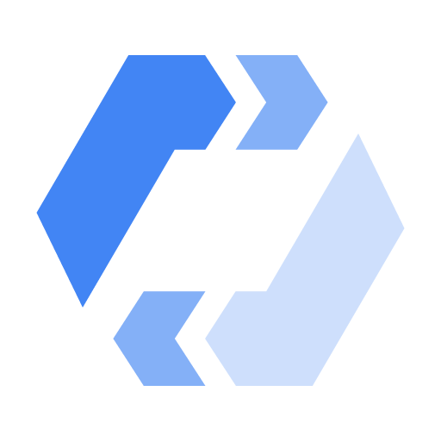

**AutoML**

Custom Machine Learning Model training and development.

AutoML is a service that can be used by developers to train models without having extensive knowledge of data science. As an example, by providing labeled samples to AutoML, it can be trained to recognize objects that are not recognizable by Vision API.

The following are the labeled samples of AutoML:

* AutoML Translation
* AutoML Natural Language and Vision

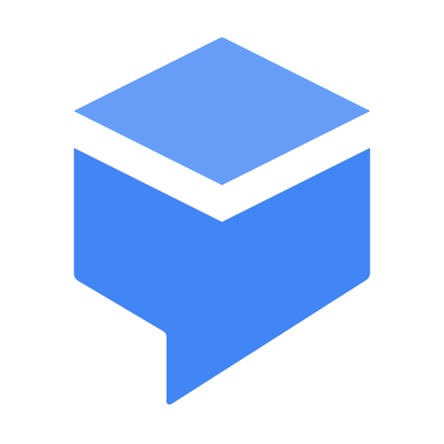

**Dialogflow**

Conversational applications and system development suite for virtual agents

This is a service that allows you to build conversation applications that can interact with human beings. The interface can interact with many compatible platforms, such as Slack or Google Assistant. It can also integrate with Firebase functions to integrate with third-party platforms using common APIs.

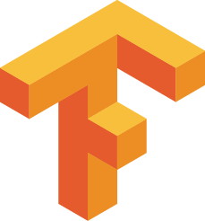

**Tensor Flow**

An Open-source tool to build and run neural network models. Has wide platform support: CPU or GPU; mobile, server, or cloud.

## 2.6 Security & Identity services



**IAM**

**Permission Management System for Google Cloud Resources**

IAM allows the GCP admin to control authorization to GCP services. Administrators can create roles with granular permissions. Roles can then be assigned to users, or preferably, a group of users.

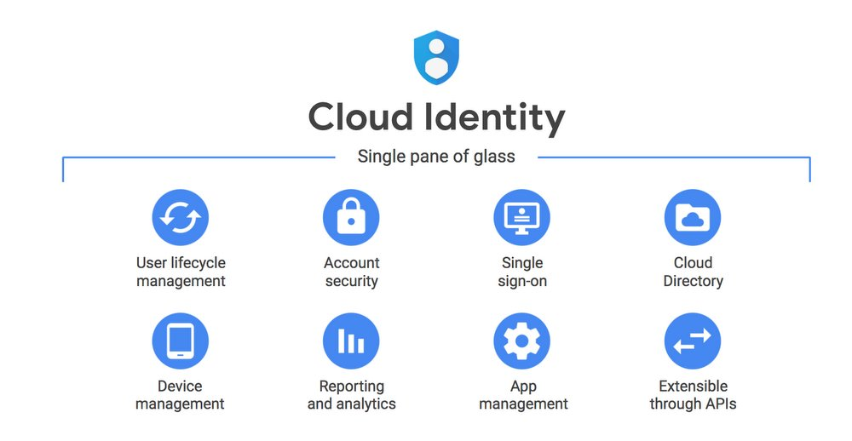

**Cloud Identity**

**Unified Platform for IT admins to manage user devices and apps**

Cloud Identity is an Identity as a Service (IDaaS) offering. It sits outside of GCP but can be easily integrated with GCP. It allows you to create organizations, groups, and users, and manage them centrally. If you already have an existing user catalog, you can synchronize it with Cloud Identity.

